**Solar Panel Energy Prediction Study**

**Abstract**

The installation of solar panel systems has increased significantly in recent years. On the one hand, the solar energy is a green energy and cost less than traditional source. And on the other hand, the weather and the position of installation will affect the efficiency of solar panel system. This study aimed to evaluate the investment of solar panel systems. To analyze the cost, users of solar panel systems can be roughly divided into residential buildings, commercial buildings and farms. And in this study, various factors such as weather, installation costs, solar energy costs will be taken into consideration. By applying the method of investment return analysis, this study will eventually give this investment a reasonable evaluation.

**Introduction**

There are many pros and cons of solar power where the solar energy is the cleanest and most ironic renewable energy source available, according to the Solar Energy Industries Association (SEIA). One benefit of solar energy is that solar energy is a renewable energy source. “As long as there is sun, solar energy will be accessible, Shireen Campbell et al. (2020).” Solar energy is available all day in all areas in the world. Another gain is that solar energy systems require low to no maintenance. The solar panels and arrays only need to be cleaned a few times per year in order to maintain their effectiveness. One widely views pro is the reduction of electricity cost. Using solar energy can offer clients (residential or business or farmers) a drip in their current electricity bill. The amount of the drop will be dependent upon the size of the system and how much electricity is used into their residentials or commercial buildings or farms.

The other flip of the coin, there are also disadvantages to utilizing a solar energy system. One of the most noteworthy disadvantages is the initial cost of the system and ROI (Return of Investment). The cost of a solar energy system can overshadow the desired benefit. Once the cost of the system, installation, and loan amounts are calculated, the system may turn out to not be in the best economic feasible for the client. Another major factor that is in direct correlation is the fact that solar energy systems are weather dependent. The efficiency of these systems is dependent on sunlight. Though some energy can be collected on rainy and cloudy days, there will be a noticeable drop in production. Solar energy cannot be collected at nighttime so those days that rain or clouds are present will present much of an issue for customers with these systems.

**Literature Review**

**Average Cost of Solar Panel Systems**

According to the introduction of ZENenergy (2020), the cost of solar panels Installation depends on many factors. For instance, daily energy usage, sunshine hours and the amount of sunlight exposure, the solar panels themselves. Daily energy usage determines the lower limit of the size of the solar system. The users need enough solar panels to guarantee their daily energy needs. The sunshine hours and the amount of sunlight exposure of residents’ home depend on some factors. For example, the roof angle and orientation, the regions they live in and the weather. And The price of solar panels also varies in different countries and regions.

Depending on the introduction of GREENMATCH (2020), Solar system is consisting of solar cells. And Solar cells come in all kinds of different shapes and sizes. The bigger the solar panel system, the more electricity is generated. The power of solar panels is measured in kilowatt hours (kWh) which can represent the size of a solar panels system.

**Residential Buildings**. For residentials, their energy usage varies a lot. Compared with commercial buildings and farms, their electricity demand is not large. Therefore, they often use the small rooftop solar panel systems. To analyze the cost of solar systems in USA. There are some reports show the average cost of solar panel systems installation in USA for residential buildings.

By the introduction of Evergreen Solar (2018). In 2016, the average cost to install a solar panel was $3 to $4 per watt. And the average solar photovoltaic system Americans normally install in their homes is about 5 kW (5000 watts). At these rates, most individuals can install a solar system in their homes for about $12,500.

And data collected by energysage (2020) shows that. In USA, the cost of solar panel systems before tax credits is about: 2 kW panel system costs $5,920, 3 kW panel system costs $8,880, 4 kW panel system costs $11,840, 5 kW panel system costs $14,800, 6 kW panel system costs $17,760. the cost of solar panel systems after tax credits is about: 2 kW panel system costs $4,381, 3 kW panel system costs $6,571, 4 kW panel system costs $8,762, 5 kW panel system costs $10,952, 6 kW panel system costs $13,142.

For a single solar panel, the cost varies in different countries and regions. According to the data given by EnergySage (2020). In USA, Solar panel costs for an average-sized installation in the U.S. usually range from $11,144 to $14,696 after solar tax credits, and the average price per watt for solar panels ranges from $2.51 to $3.31.

**Commercial Building.** In USA there are many solar panels systems are installed in the commercial Buildings. In general, they require more energy than residential buildings. Therefore, the cost of solar panels system is much bigger than that of residential buildings.

According to the introduction of KUBY (n.d.). “Commercial solar systems follow the same general trends and guidelines as shown above in the residential solar cost breakdown. The key difference is that commercial solar arrays are generally quite a bit bigger, ranging from 15kW to 250kW+. And the price continues to drop as the scale increases. Large systems may drop to < $1.50/W fully installed. Commercial solar power systems in the 50kW to 200kW range will cost approximately $100,000 to $350,000. Also, there are tax incentives for commercial solar energy systems. All of these factors make businesses an ideal candidate to install solar panels”.

**Farms.** The electricity demand of farms is much larger than that of small commercial buildings and residential buildings.In addition to installing rooftop solar panel systems, community solar panel systems are more efficient for farms and some commercial buildings. The most typical community solar panel system is solar farm. By introduction of EnergySage (2020), “A community solar project is a solar power plant whose electricity is shared by more than one property. The primary purpose of community solar is to allow members of a community the opportunity to share the benefits of solar power even if they cannot or prefer not to install solar panels on their property. Project participants benefit from the electricity generated by the community solar farm, which costs less than the price they would ordinarily pay to their utility”.

According to the introduction of KUBY (n.d.). “Typical commercial or farm solar power systems will fall in the $40,000 to $200,000 range; the large range is due to the vast differences in commercial and farming operations.  Community, large commercial and small utility solar farms will fall in the $1Mn to $11Mn range; once again, the large range is due to the differences in potential capacity needs.  If you would like to participate in the Small Power Producers Program, expect a 1MW solar farm in the $1.5Mn range +/- 20%.”.

**Changes of solar panel system cost**

**Installation.** Data collected through Quarter 4 of 2019 show that North Carolina ranked 6th nationally for solar installation in 2019, Shireen Campbell et al. (2020).” It also shows that North Carolina installed enough solar to power over 722,000 homes. North Carolina’s solar industry grew obviously since of the state’s Renewable Energy Efficiency Portfolio Standard. Figure 1, below from the SEIA, shows the annual amount of solar installations in North Carolina over the last 9 years.

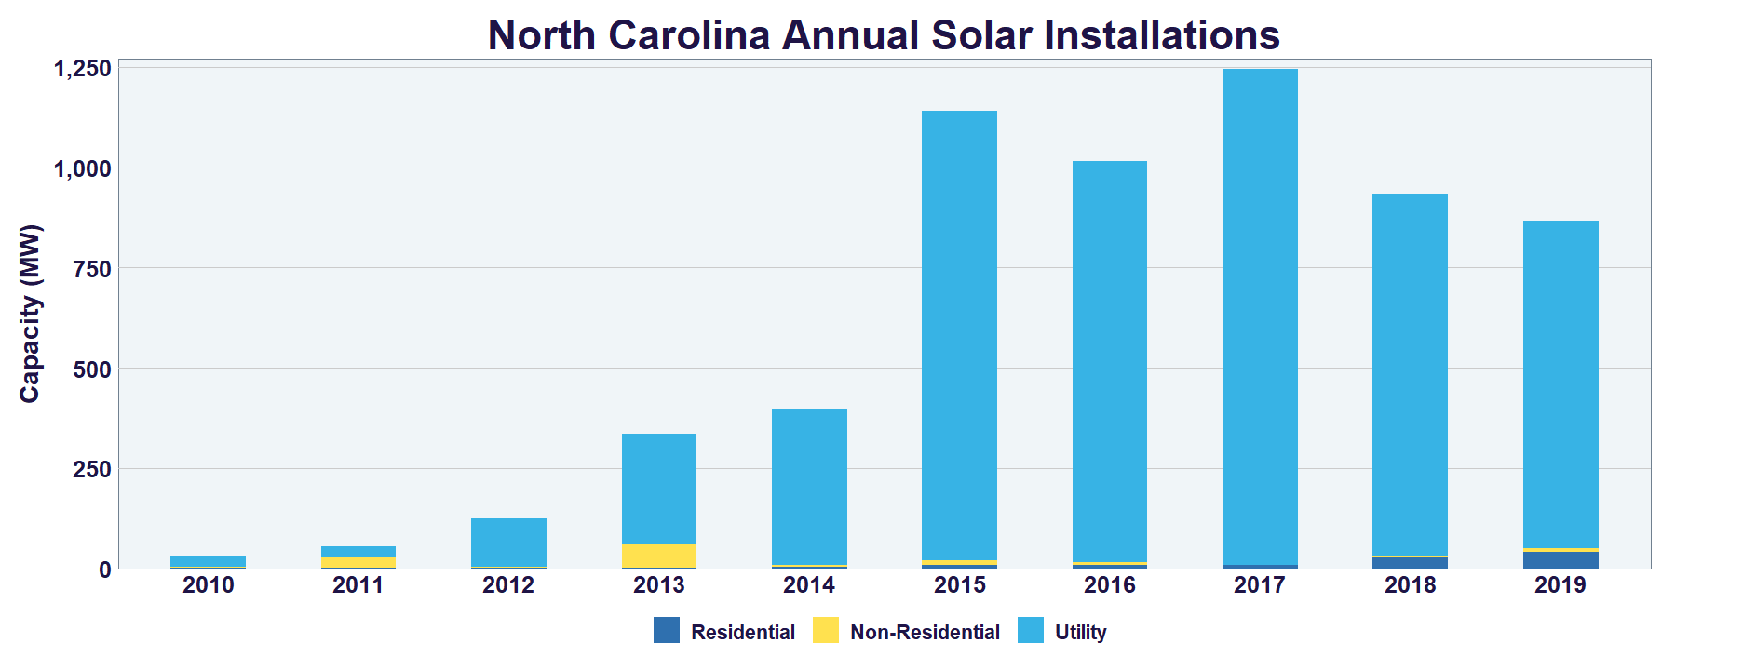

*Figure 1: North Carolina Solar Installations*

**Cost.** According to Matasci (2020), “Changes in solar panel cost over time can be explained by Swanson’s Law, which states that the price of solar PV modules decreases by about 20 percent for every doubling in global solar capacity.” The average cost of solar panel installation over the last 10 years have significantly dropped and it is predicted that this trend will continue in the years to come. Figure 2, below from EnergySage, shows the drop in the gross cost per watt over a 4-year period. Even with the drop in the cost of solar panels, utility lawyer Brian Potts (2015) believes that the rooftop solar “craze” is hindering the growth of more cost-effective renewable power sources. Though a study conducted by North Carolina State, backed by the Department of Energy, shows that installing a fully financed, average-size rooftop solar system would reduce energy costs for 93% of the single-family households in the 50 largest American cities today.

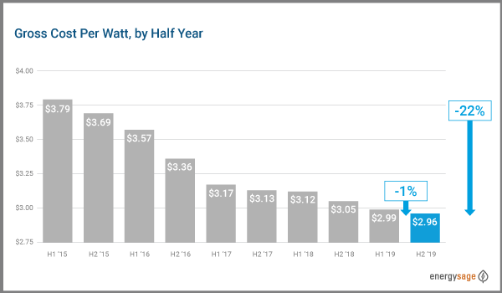

*Figure 2: Shows drop in gross cost per watt*

**Methodology**

To answer the proposed research question, I would utilize investment return analysis. According to Andrew Beattie (2020), “return on investment (ROI) is a financial metric that is widely used to measure the probability of gaining a return from an investment. It is a ratio that compares the gain or loss from an investment relative to its cost. It is as useful in evaluating the potential return from a stand-alone investment as it is in comparing returns from several investments”.

We consider the cost of solar panel in different factors. By taking Weather and rain, Cost of solar panel kits Average solar cost all into consideration to get the data of the cost of solar panels system for different users and regions. And to study the return of the solar panels system. We compare the cost of the solar panel system with the traditional electricity cost and get the return.

And also, the prediction of ROI in times series is needed since the cost of solar panels is decreasing in recent years. By using algorithms on ML and AI, the ROI in the future will be predicted.

Through data collection, visualization, and prediction, we can make a reasonable evaluation of the investment in the solar panel system.

**References**

* NC Clean Energy- Technology Center- NCSU, Template Solar Energy Development Ordinance for North Carolina NC Clean Energy Technology Center

<https://nccleantech.ncsu.edu/>

<https://www.energysage.com/nccleantech/>

* About Solar Energy. (n.d.). Retrieved from <https://www.seia.org/initiatives/about-solar-energy>
* Matasci, S. (2020, January 8). How Solar Panel Cost & Efficiency Change Over Time: EnergySage. Retrieved from <https://news.energysage.com/solar-panel-efficiency-cost-over-time/>
* Potts, B. H. (2015, May 17). The Hole in the Rooftop Solar-Panel Craze. Retrieved from <https://www.wsj.com/articles/the-hole-in-the-rooftop-solar-panel-craze-1431899563>
* Pros and Cons of Solar Energy. (2020, March 10). Retrieved from <https://www.greenmatch.co.uk/blog/2014/08/5-advantages-and-5-disadvantages-of-solar-energy>
* Zhao, D., Mccoy, A., & Du, J. (2016). An Empirical Study on the Energy Consumption in Residential Buildings after Adopting Green Building Standards. *Procedia Engineering*, *145*, 766–773. doi: 10.1016/j.proeng.2016.04.100
* NCHRP PROJECT 25-25 TASK 64: Feasibility Study of using Solar or Wind Power for Transportation Infrastructure:

<http://onlinepubs.trb.org/onlinepubs/nchrp/docs/NCHRP25-25(64)_FinalHandbook.pdf>

<https://content.ces.ncsu.edu/what-is-solar>

<https://www.seia.org/us-solar-market-insight>

* Template Solar Energy Development Ordinance for North Carolina NC Clean Energy Technology Center –

<https://nccleantech.ncsu.edu/>

<https://craven.ces.ncsu.edu/considerations-for-transferring-agricultural-land-to-solar-panel-energy-production/>

* Cost of Solar Energy:  Article with comments from John Morrison, chief operating officer of Strata Solar in Chapel Hill, <https://www.carolinajournal.com/news-article/n-c-state-prof-casts-shadows-on-solar-meeting/>
* How Many Solar Panels Do I Need? (n.d.) Retrieved from

<https://www.zenenergy.com.au/solar-panels/how-many-solar-panels-do-i-need/>

* Why Solar Panels in the UK Are a Great Option? (2020, July 27). Retrieved from <https://www.greenmatch.co.uk/solar-energy/solar-panels>
* Pros and Cons of Solar Energy. (2020, March 10). Retrieved from <https://www.greenmatch.co.uk/blog/2014/08/5-advantages-and-5-disadvantages-of-solar-energy>
* Solar Panel Installation: How Much, How To, and Upkeep (2018). Retrieved from

<https://evergreensolar.com/installation/>

* How much do solar panels cost in the U.S. in 2020? (2020, July 15). Retrieved from

<https://news.energysage.com/how-much-does-the-average-solar-panel-installation-cost-in-the-u-s/>

* The Cost of Solar Panels (n.d.). Retrieved form <https://kubyenergy.ca/blog/the-cost-of-solar-panels>
* Community solar: what is it? (2020, July 15). Retrieved from <https://www.energysage.com/solar/community-solar/community-solar-power-explained/>
* Information and Cost of Solar Panels in Saskatchewan (n.d.). Retrieved from <https://kubyenergy.ca/blog/information-and-cost-of-solar-panels-in-saskatchewan>
* Andrew Beattie (2020, August 31). A Guide to Calculating Return on Investment (ROI). Retrieved from <https://www.investopedia.com/articles/basics/10/guide-to-calculating-roi.asp>
* Read more at: <https://craven.ces.ncsu.edu/considerations-for-transferring-agricultural-land-to-solar-panel-energy-production/>
* <https://www.energystar.gov/about/federal_tax_credits>
* <https://southern-energy.com/>
* <http://www.sas.com>
* <https://blogs.sas.com/content/subconsciousmusings/2018/07/05/deep-learning-forecasts-solar-power/>
* Shireen Campbell, Georgios Kiriazidis, Prethesh Thomas, Majed Al-Ghandour (2020), “Cost Efficiency of Solar Panel Installation “- class project report - BIDA 650, Fayetteville State University.